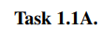

**Run the program with the root privilege:**

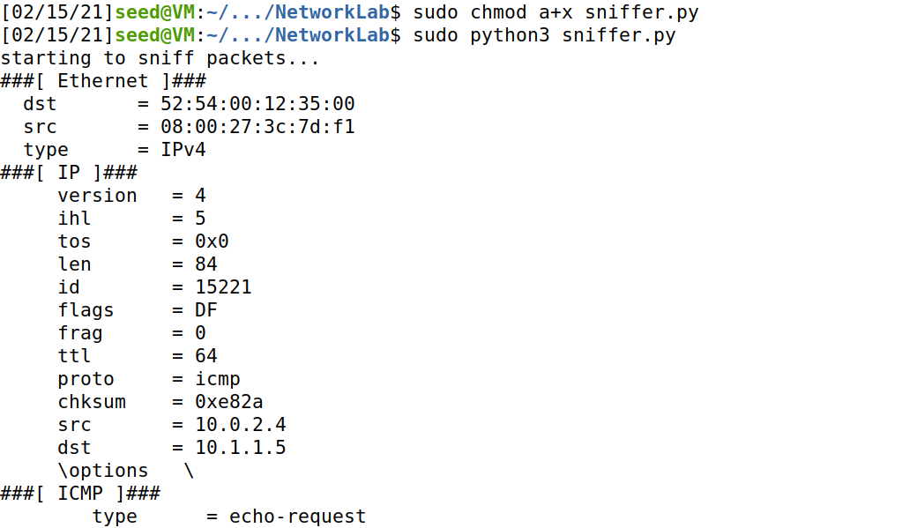

**run the program without the root privilege:**

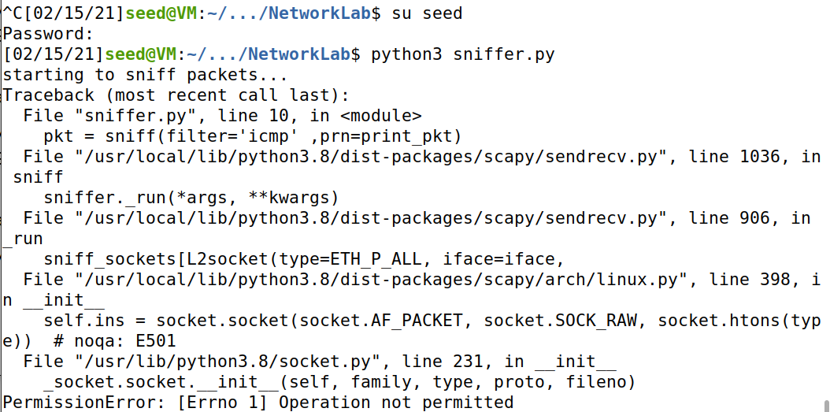

**As we see, when we run with root privilege we can sniff packet without no errors but when we run it without any sudo permission we found that we get an issue to use the sniffer function due to that we don’t have any permission to init the socket because we don’t have the permit to get socket info that from the network devices.**

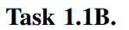

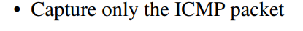

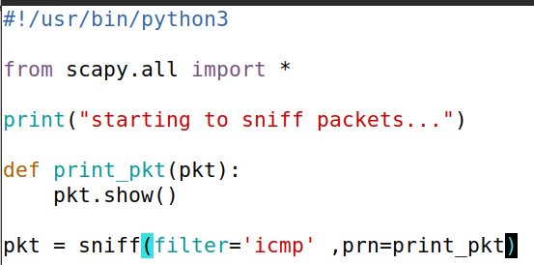

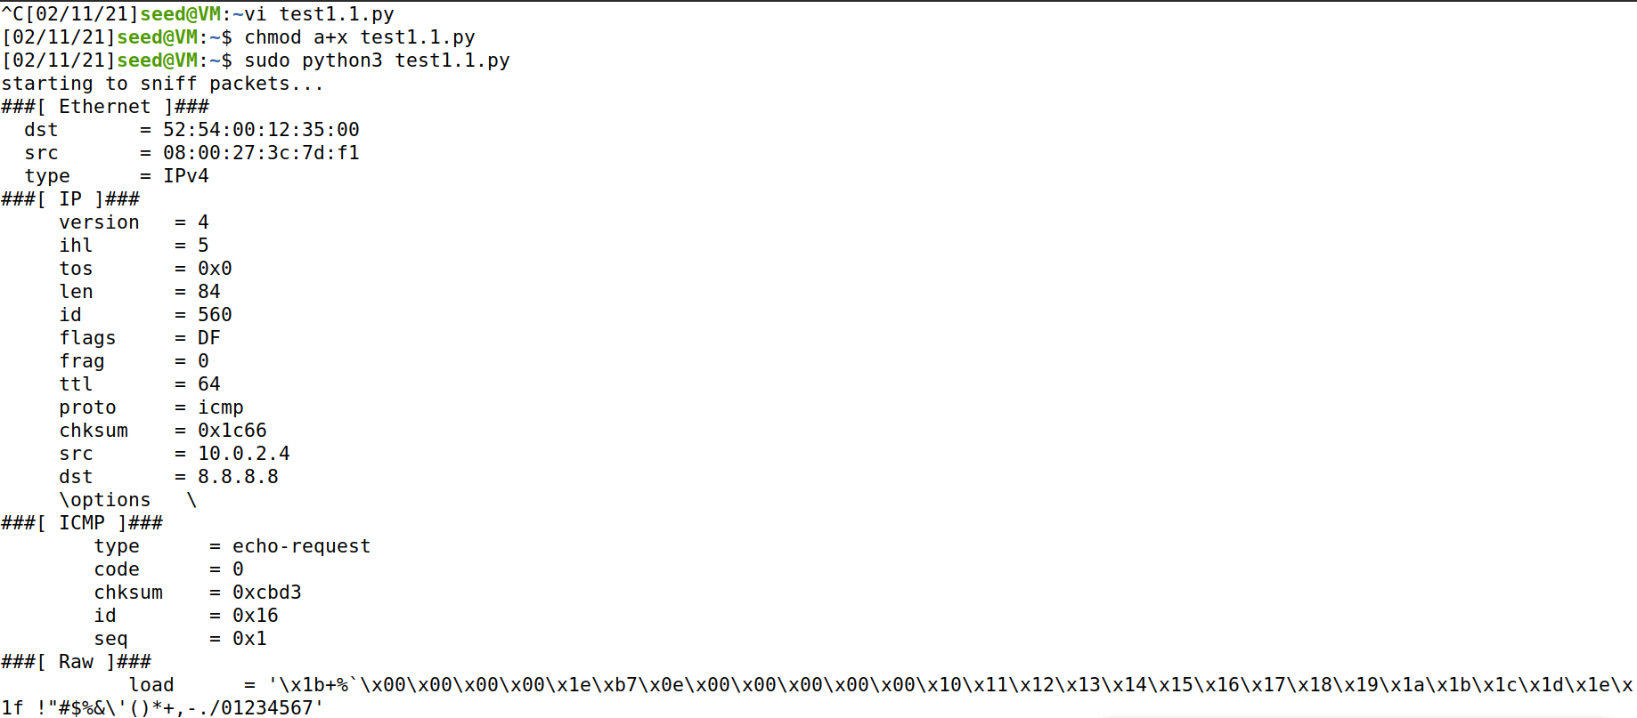

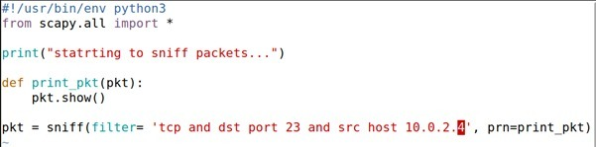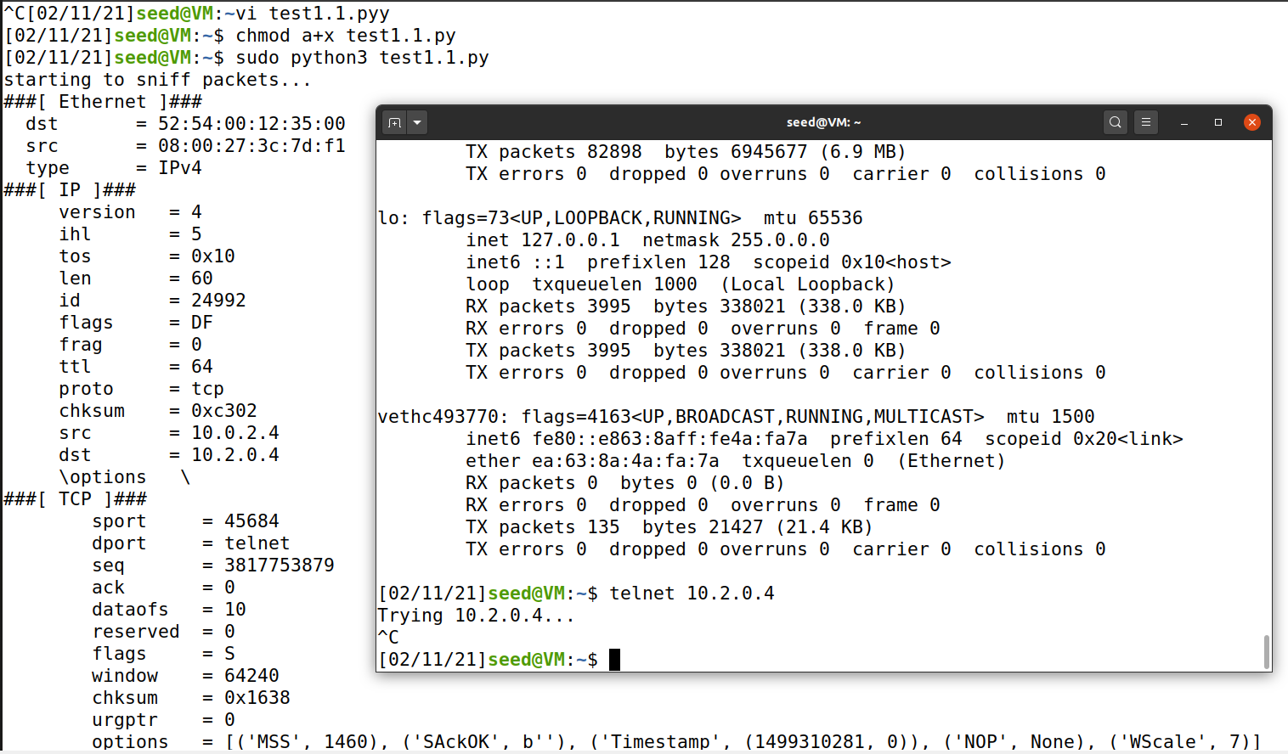

**As we can see the dport type is telnet, and as we know telnet port is 23 which means the dest port is 23 as requested.**

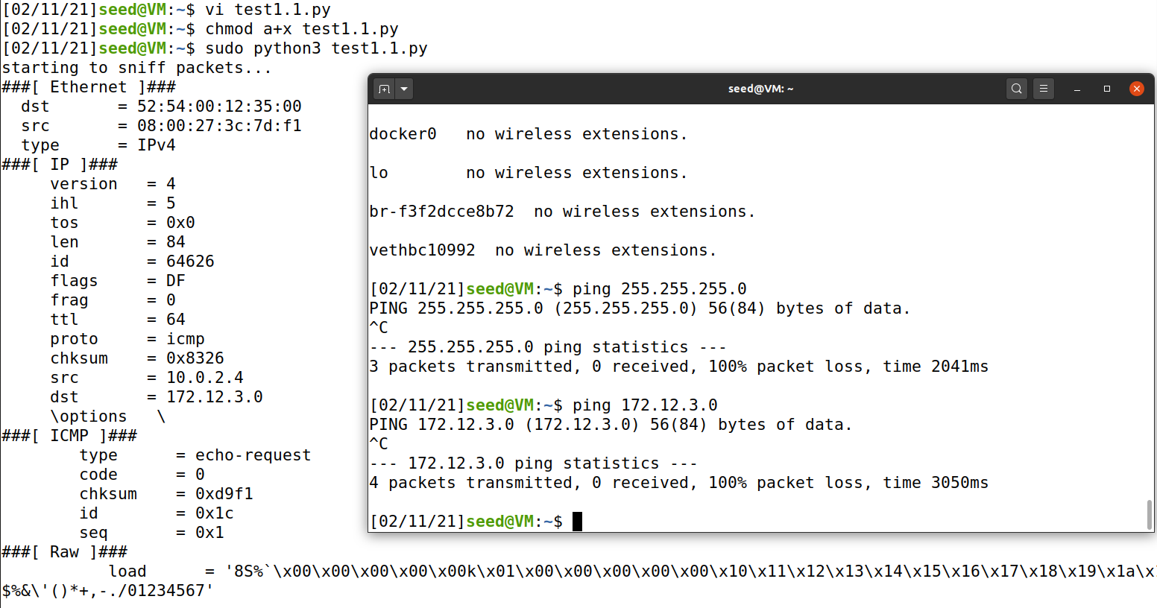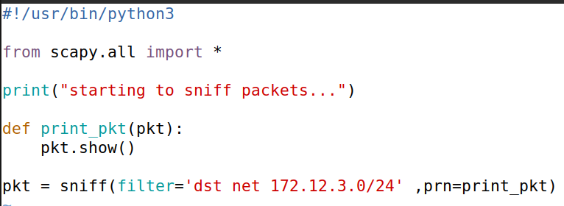

**As you request from us we should any subnet that our VM isn’t attached to, so we did pick this particular subnet. as we can see we chose the subnet to 172.12.3.0/24 and we send the ping packet to ip 172.12.3.0 and we sniff this specific packet as requested**.







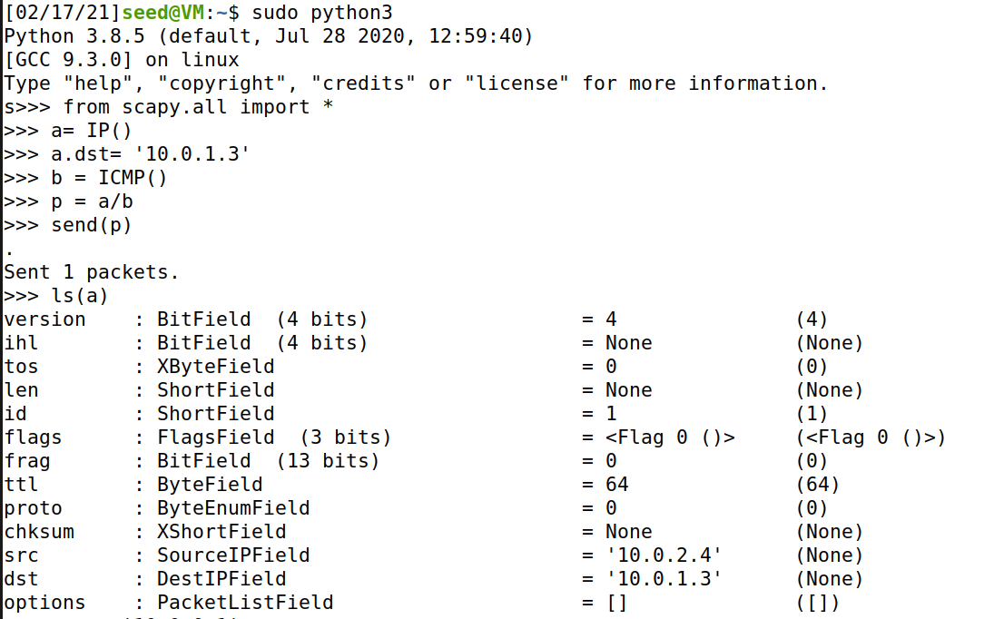

**As we see we haven’t set the a.src yet so the source IP is the original one , now let’s make the spoofing by setting any arbitrary source IP address , we chose that the Source IP is 10.0.0.1 , now let’s see our spoofing:**

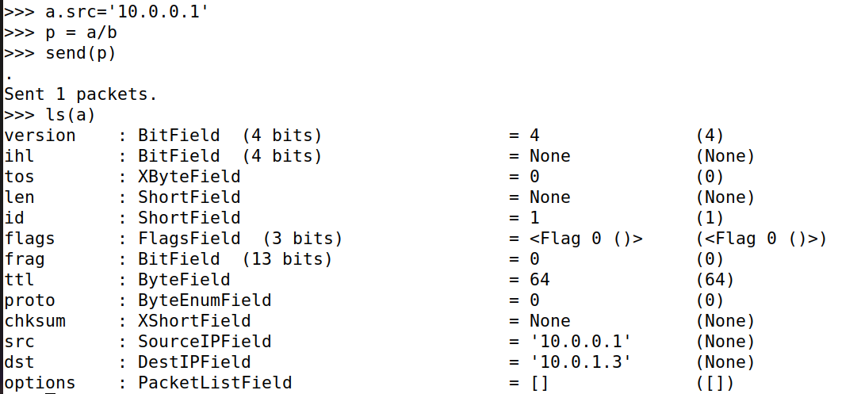

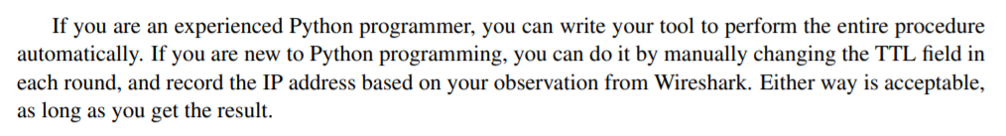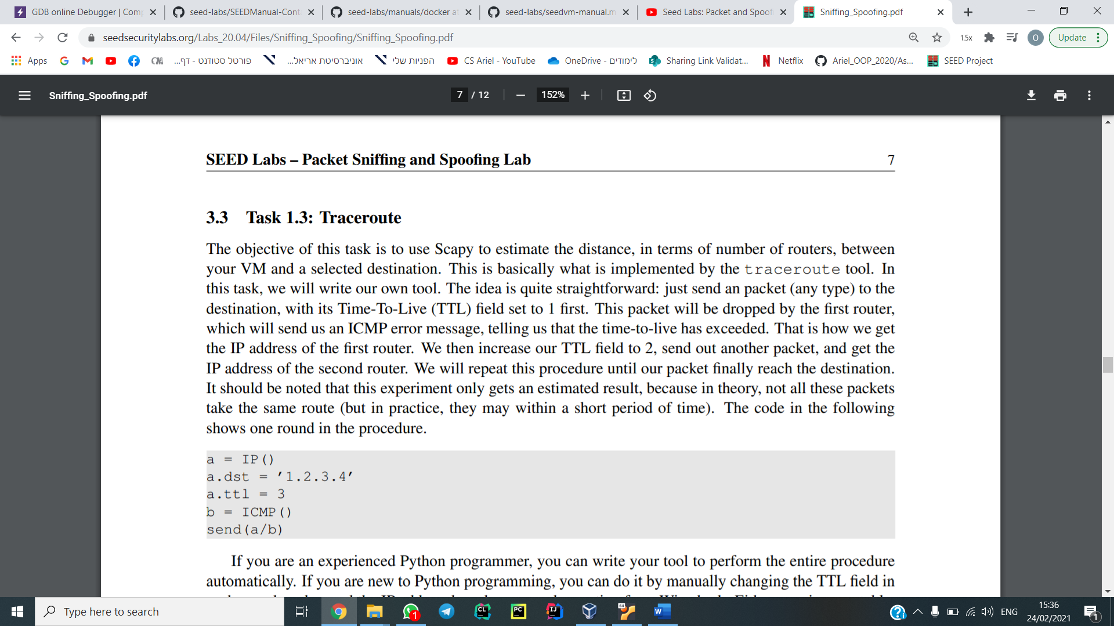

Here we can see the tool we wrote in python.

The code is meant to change the ttl field in each iteration so we don’t need to change it manually (automation):

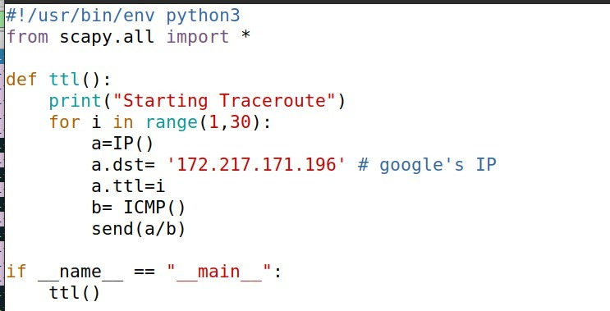

Here we can see our code running:

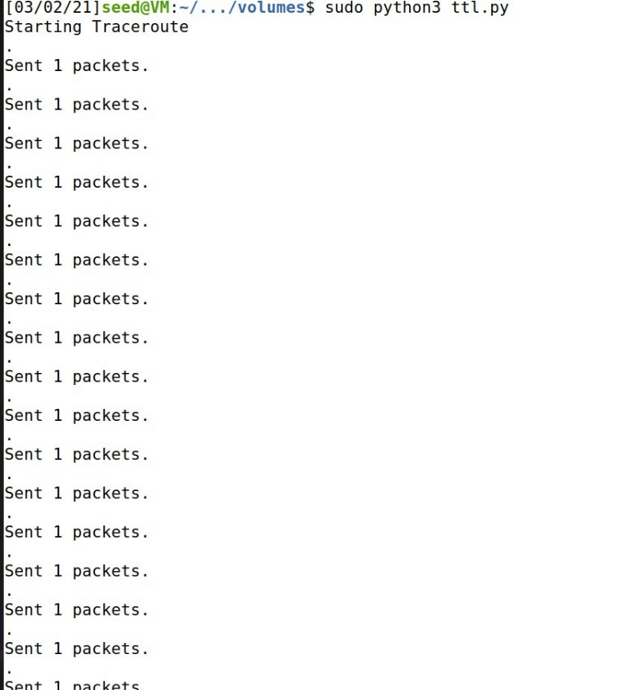

As we see, we have increased the ttl by one each time until we got the minimum ttl for the destination, we can see in wireshark program that when the ttl is low our packet doesn't got the reply from the original destination but from one of the last routes the packet came from.

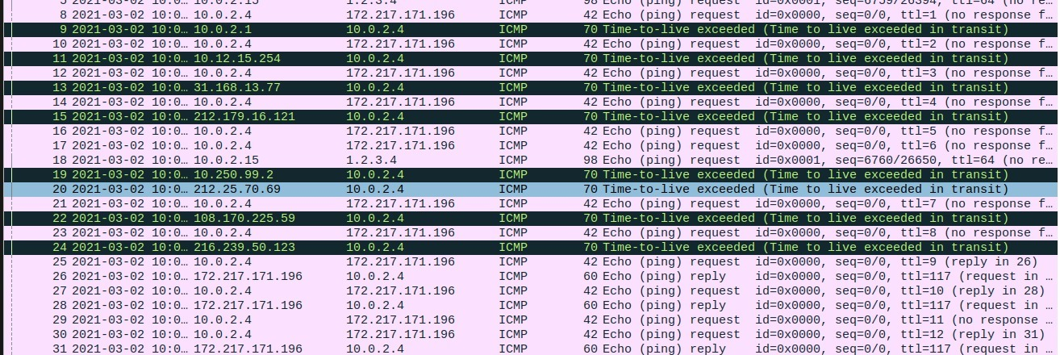

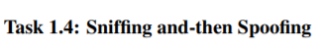

Here we can see the sniff and spoof program we wrote in python:

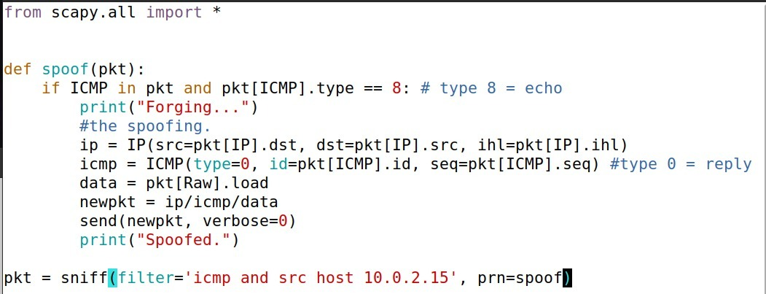

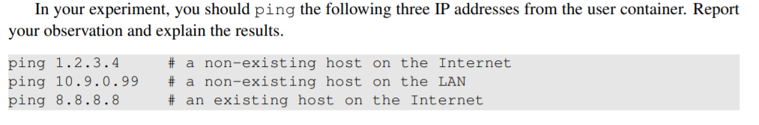

we decided to work with two VM to demonstrate the sniff and spoof technique.

in left window we have the host network and in the right window we have the spoof network, we send the ping packet from the host network and the attacker sniffing that packet and then send to the host a fake reply(spoof) - as we can see (in the pictures). That happen even though that destination doesn't even exist.

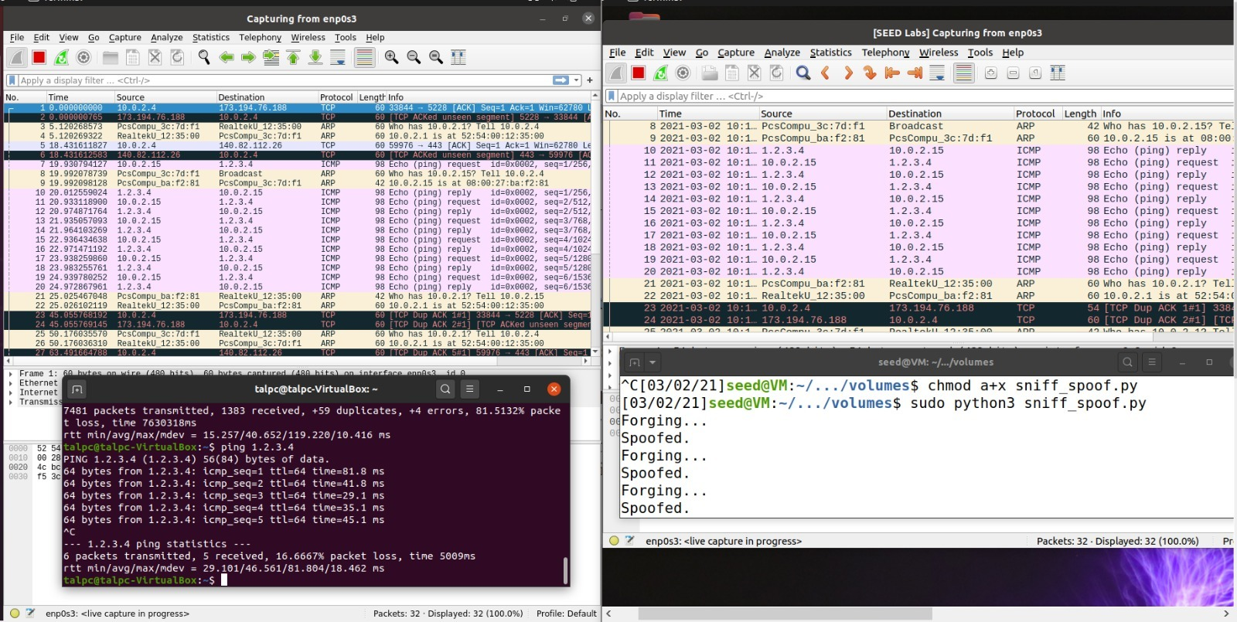 we can see the fake reply here in wireshark program: ping to 1.2.3.4:

ping to 10.9.0.99:

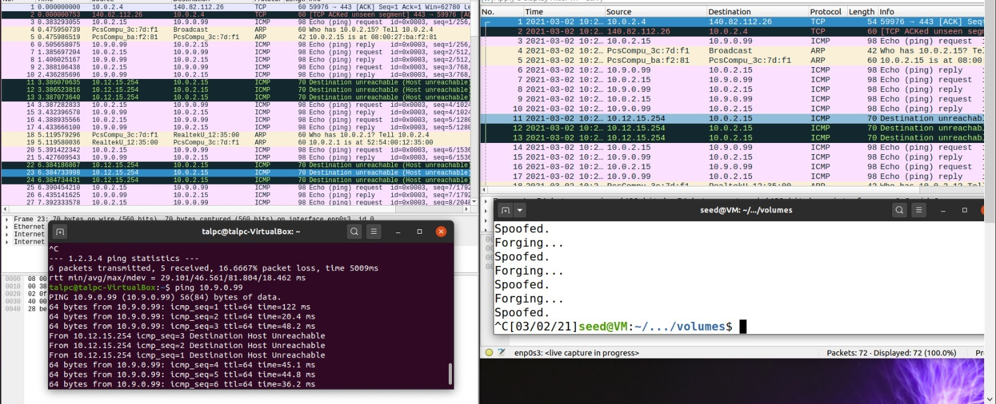

Ping for 8.8.8.8:

here we found that we got two reply for each request, and that's happened due to the spoof that send his reply before the original destination reply (google in that case).

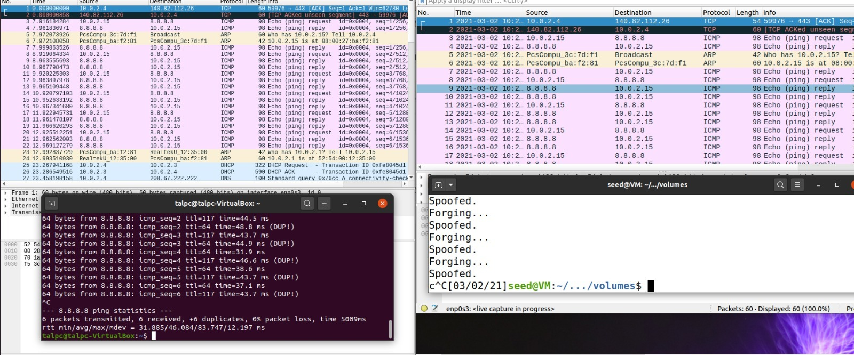

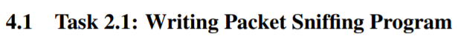

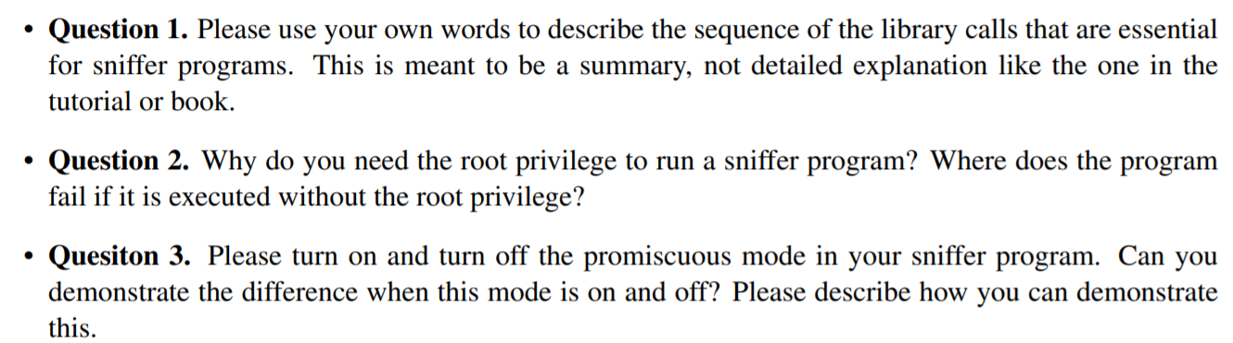

**Answer 1:**

Initially we are going to open a live pcap session.

The live pcap method which gets a device name (the one we want to sniff on), will create a raw socket which we can use for our sniffer.

Finally we will capture the packets by pcap loop which gets a void function as argument (callback function) - Which will print for us the packet’s data (proto type, source IP, destination IP).

**Answer 2:**

when we call the pcap_open_live method it creates a raw socket which we can transfer packets through. In order to create a raw socket there is need in bind function which cannot work without root permissions.

if we try to run it without root permissions we will get an exception tells us we don’t have permissions to execute it. The exception will be thrown by the bind function.

**Answer 3:**

We can turn on and off promiscuous mode by the third argument in pcap_open_live method which is int – true or false (1/0). When we put 1 (at third argument) promiscuous mode will be enabled. Else 0 – disabled (normal mode).

When promiscuous will be disabled – the host will be sniffing only traffic that is related (to, from, or routed by) to it.

When promiscuous will be enabled – all the network traffic will be sniffed even if its not related to the host. Clearly promiscuous mode will provide us more packets to sniff then the normal mode.

